XX
Title of your abstract in lower-case letters, 20pt Arial font, centered.

Author Name¹, Presenting Author Name² and Author Name²
¹Department, Institution, Address – all in 12pt Arial, Italic, centered.
²Author names in 14pt Arial, centered. Presenting author should be underlined.
Email: the email of presenting author – 12pt Arial, centered.

We recommend using this document as a template for the abstract, this way you will not need to change any styling – only the text. The abstract should be a summary of your work including a short introduction, results and conclusions. The abstract text should be written in Arial font, 12pt. All the text should be in one column, justified. The abstract should not exceed one page. Number citations consecutively in square brackets [1]. Punctuation follows the bracket [2]. The number at the top of the page will be provided by the organizers.
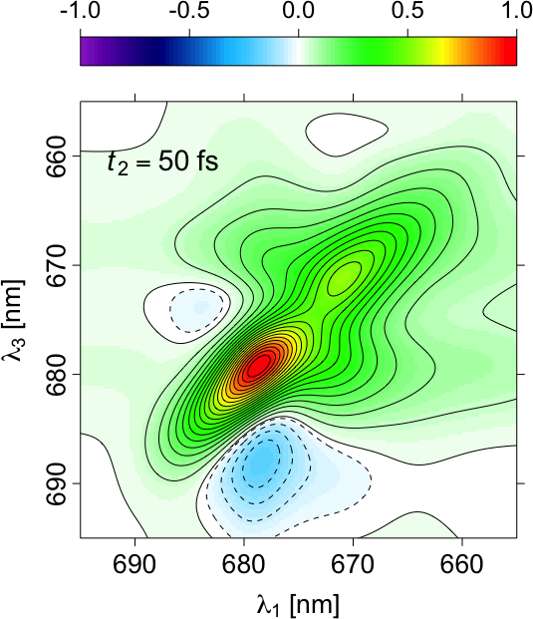Fig. 1 Short and clear caption, revealing the message of the figure.
We recommend to place figures and corresponding captions in a text-box to avoid any formatting issues. Captions should be in Arial 10pt, placed below the corresponding figure and centered across the width of the figure. Figure labels and axis values should be big enough to be readable. The abstract book will be printed in color.
Table captions should be placed above the corresponding table and aligned-left. These captions should also be in Arial 10pt.
Number equations consecutively with equation numbers in parentheses flush with the right margin, as in (1). To make your equations more compact, you may use the solidus (/) and the exp function, etc. Use parentheses to avoid ambiguities in denominators. Punctuate equations with commas or periods when they are part of a sentence, as in
${\left(1+x\right)}^{n}=1+\frac{nx}{1!}+\frac{n\left(n-1\right)x^{2}}{2!}+…$ . (1)
Symbols in your equation should be defined before the equation appears or immediately following.

REFERENCES
[1] M. King, B. Zhu, and S. Tang; Mobile Robots 8 (2001) pp. 520-531.
[2] H. Simpson, Dumb Robots, 3rd ed., Springfield: UOS Press (2004) pp.6-9.

